Killers of the Three Kingdoms

Problem Statement

Haodong Liu

Xiangtian Li

(Jackie) Xiangqing Zhang

# Signatures

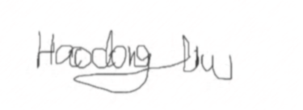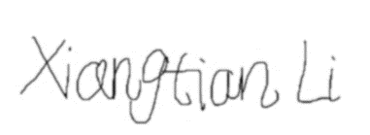 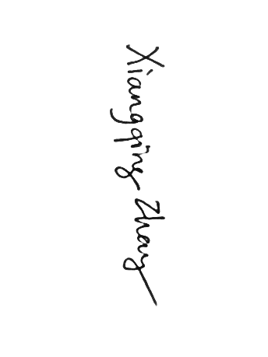

Table of Contents

Signatures 1

Version Information 3

Executive Summary 3

Introduction 3

Main Content 4

Game Rules 4

Roles And Objectives 4

Terminate Conditions 4

Heroes’ Attributes 4

Life Points 4

Special Abilities 4

Possessions 4

Death 5

Gameplay 5

Feature List 5

Scope 6

Out of Scope 6

Key Stakeholders 7

References 7

Appendix A: UML Class Diagram 8

Appendix B: Game Board Diagram 9

Index 10

Glossary 10

# Version Information

|  |  |
| --- | --- |
| Date | Comments |
| 03/25/2015 | Initial draft. |
| 03/26/2015 | Added UML Class Diagram. |
| 05/15/2015 | Revised Problem Statement. |
| TBA | TBA. |

# Executive Summary

In this document, we will go through the idea of this project and describe how we will solve the problem related to it. First, we provide the summary of it, followed by a brief introduction to our project. Then, we will examine the problem in different levels, including game rules, feature list, scope and key stakeholders. An UML diagram (Class Diagram) and the draft of game board is attached to this statement. For more information, see Appendixes below.

*Legends of the Three Kingdoms* [1], also known as 3KK, is a Chinese card game based on the Three Kingdoms period of China. There exists some online versions of this game; however, none of them is in English. Also, the existing game is too complicated to understand for a starter [2]. Therefore, we are seeking for possibilities to make a simplified English version of 3KK, allowing starters in the world to learn this strategy game. We also want to make this game offline so that people can access it and practice with AI as long as a computer can be reached. For simplicity purpose, we will assume that the gameplay always consists of five players (i.e. one human player and four computer AIs).

# Introduction

This document is the first document of our CSSE 376 project called *Killers of the Three Kingdoms*, which describes our application and contains an contains a UML Class Diagram that shows the class and interface structure. Following this document will be some milestone reports that shows our progress. This problem statement will give an overview of the entire project, letting readers know its game rules and listed features. In the UML Diagram, we will see the data structure of this application, as well as the logical relationship between these data models. In the Game Board Diagram, we will show the GUI framework of this application.

# Main Content

Before we examine any highlighted features of our project and our application, we would like to introduce the basic game rules of this game.

## Game Rules

### Roles And Objectives

The game consists of several roles. Each role has its own winning conditions.

* **Monarch (1 player)**: Beat (namely “kill”) all the rebels and traitors.
* **Minister (1 player)**: Protect the monarch because their objectives are the same as monarchs’.
* **Rebel (2 players)**: Kill monarch without leaving the traitor as the last survivor.
* **Traitor (1 player)**: Death of all other players and then monarch.

### Terminate Conditions

The game ends immediately as long as one of the following situations happen:

* The monarch is killed
* All rebels and traitors are killed

Even if the player itself was killed before the game ends, it can still claim victory if the objectives of its role are completed.

### Heroes’ Attributes

Each player will be assigned to play a hero, as well as one of the four roles associated with the hero. Unless death, each player cannot reveal its role. As a hero, the player will have the following attributes.

#### Life Points

Each hero has his or her own life points (or health points). Life points, in general, vary from three points to five points. If a hero’s health is less than one point, he or she will be immediately requested to take actions. More details will be covered below.

#### Special Abilities

Some heroes have special abilities to use. These abilities include but not limit to:

* Abilities to manipulate cards in the deck
* Abilities to change the behaviors of certain cards
* Abilities to change certain game rules

#### Possessions

All heroes have the ability to possess a number of cards that is equal to their health points. Generally speaking, these cards include:

* **Basic cards**: three types of cards exist in this category: **Kill** (deals one damage to another hero), **Dodge** (avoids damage from a Kill card), and **Peach** (heals a hero by one life point).
* **Equipment cards**: These cards can be equipped by heroes in order to increase heroes’ attach range, defense abilities and so on.

#### Death

When a hero’s health is less than one point, he or she will be put into Near Death state, and must take one of the following actions:

* Use a Peach card that he or she possesses. If he or she does not have a Peach card,
* Other players that have the same objectives try to save him or her by a Peach card.

If the hero’s life point is positive after the action, he or she survives. Otherwise, the hero dies, reveals his or her role and discards all cards. If his or her role happens to be rebel, the player that kills him or her can draw three cards.

It is also necessary to point out that if a player’s health is less than zero, he or she will need more than one Peach cards to survive.

### Gameplay

There are five stages of the game.

* **Initial**: Some heroes’ special abilities to manipulate cards will be triggered.
* **Drawing**: Each player draws two cards from the deck. Heroes with certain special abilities may draw more than two cards.
* **Action**: Each hero in turn can play any number of cards.
* **Discard**: After the action stage, each hero must discard cards in his or her hand so that the number equals to his or her life points.
* **End of the turn**: Some heroes may use their special ability in this stage.

## Feature List

Due to the complexity of this game, our team discussed and agreed to include the following features in this project:

* Be able to start the game by clicking on the “start” button
* Be able to abort the game by clicking on the “abort” button,
* Be able to restart the game in any time so that everything is set to initial state.
* Be able to let AI players play cards and take actions:
  + Be able to draw cards
  + Be able to equip and use cards
  + Be able to discard cards
* Be able to show all needed information on the GUI, including:
  + **Game start**: allows user to start or quit the game
  + **Game play**: allows user to draw and view cards on hand, take actions, interact with AI players, and abort the game
  + **Game end**: indicates the result of the game. Specifically, announces which role wins the game.
* Be able to handle the gameplay, including five stages and deal with different events.
  + Be able to assign random heroes to players
  + Be able to assign random roles to players
  + Be able to perform five stages in turn
  + Be able to let players draw cards
  + Be able to record and deal with card actions, such as to damage, to dodge, and to heal
  + Be able to record and deal with hero attributes, such as life points, special abilities, possessions, and events triggered by Near Death state.

## Scope

These are some aspects that we would consider in this project.

* Test Driven Development (TDD) and unit tests for business logic of the application
* Simple Graphical User Interface (GUI)

## Out of Scope

These are some aspects that we would assume not to consider:

* Game modes that require more than or less than five players
* Fancy animations and graphical special effects
* Extension packs other than the basic version of the game

# Key Stakeholders

|  |  |
| --- | --- |
| Name | Role |
| Mark A Hays | Project Advisor |
| Xiangtian Li | Project Team |
| Haodong Liu | Project Team |
| Xiangqing Zhang | Project Team |
| Classmates (TBA) | End User(s) |

# References

[1]: *Legends of the Three Kingdoms*, Wikipedia: <https://en.wikipedia.org/wiki/Legends_of_the_Three_Kingdoms>

[2]: *Legends of the Three Kingdoms*, Official Website: <http://legendsofthethreekingdoms.com/>

# Appendix A: UML Class Diagram

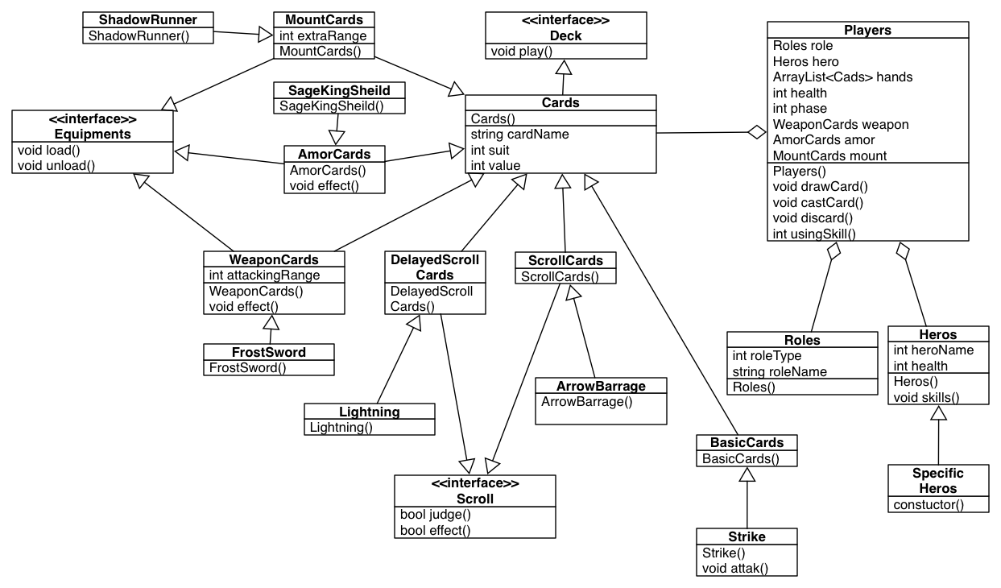

Note: it is suggested to print this diagram.

# Appendix B: Game Board Diagram (StoryBoard)

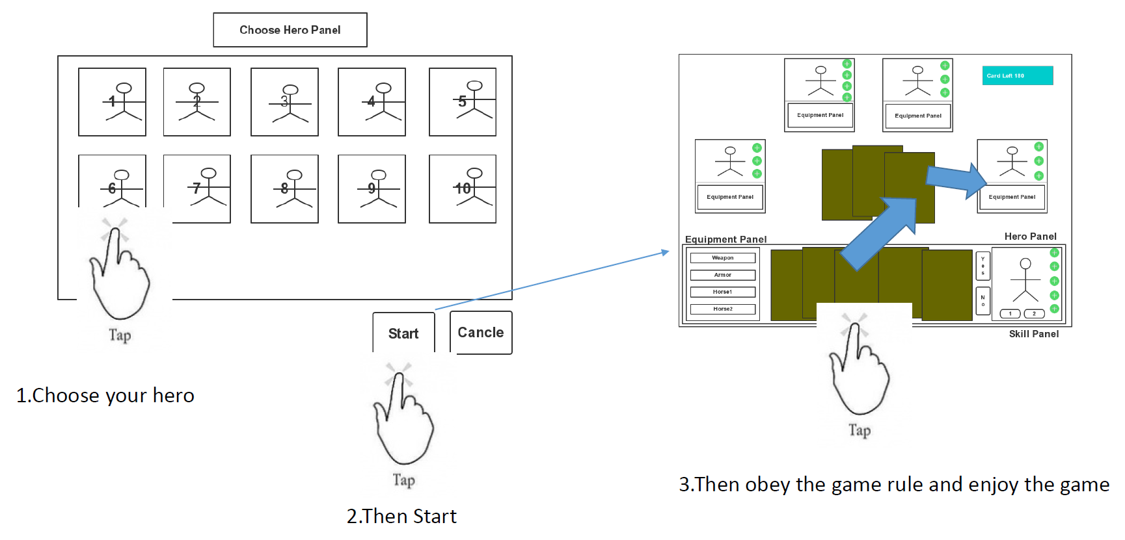

Note: it is suggested to print this diagram.

# Index

*Killers of the Three Kingdoms*. Introduction, Problem Statement, 3.

# Glossary

**Board Game**. A game that involves counters or pieces moved or placed on a pre-marked surface or "board", according to a set of rules.

**Graphical User Interface**. A type of interface that allows users to interact with application through graphical icons and visual indicators. Also known as GUI.

**Test Driven Development**. A software development process that relies on the repetition of a very short development cycle.